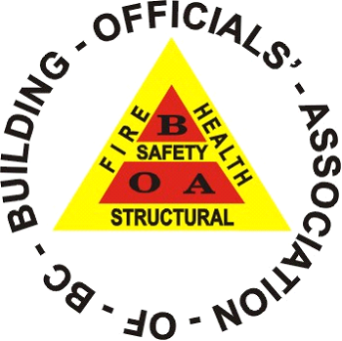
BOABC WORK EXPERIENCE VERIFICATION FORM

A Regular and/or Associate One (1) Member is eligible to apply for Certification after successfully passing the respective Building Officials’ Association of British Columbia (BOABC) Examinations and completing the required work experience while employed by a City, Municipality, Regional District or other acceptable form of Local, Provincial or Territorial Government.

[a] For Level One (1) Certification for Regular and Associate One (1) □ YES
Members, the applicant must have a work experience requirement of Two
(2) years, deemed to consist of 24 months of work within a 36 month
period.

[b] And/or Level Two (2) Certification for Regular and Associate One (1) □ YES
Members, the applicant must have a work experience requirement of Three (3)
years, deemed to consist of 36 months of work within a 54 month
period.

[c] And/or Level Three (3) Certification for Regular and Associate One (1) □ YES
Members, the applicant must have a work experience requirement of Four (4)
years, deemed to consist of 48 months of work within a 72 month
period.

[d] PLUMBING-Level One (1) Certification for Regular and Associate One (1) □ YES
Members, the applicant must have a work experience requirement of Two
(2) years, deemed to consist of 24 months of work within a 36 month
period. *

[e] PLUMBING-Level Two (2) Certification for Regular and Associate One (1) □ YES
Members, the applicant must have a work experience requirement of Two
(2) years, deemed to consist of 24 months of work within a 36 month
period.
(*both plumbing levels require two years)

SUPERVISOR VERIFICATION

I ________________________________________ hereby confirm that ________________________________________has completed the above mentioned work experience in the capacity of a Building Inspector, Plans Examiner or other (explain).

Name of Applicant: _______________________________________________________________________________________

Supervisor Name: _______________________________________________________________________________________

Supervisor Title: _______________________________________________________________________________________

Telephone: _______________________________________________________________________________________

Email: ________________________________________________________________________

__________________________________________________ ________________________________
Supervisor Signature Date

